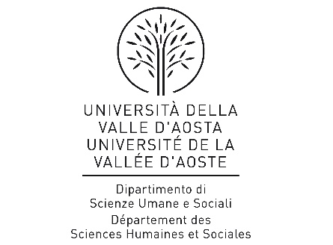
Internship Agreement
between
The Dipartimento di Scienze umane e sociali of the Università della Valle d'Aosta - Université de la Vallée d'Aoste, located in Aosta (AO), Italy Italian Codice Fiscale. 91041130070 and VAT No. _______, hereafter designated “the University”, represented by Prof. Carlo Maria BAJETTA, born in Milano (MI), Italy, the 17rd of August 1966

and
(Name of host company)__________________________________ located in ___________________________________, tax code (if applicable)_________________ and . VAT No. _______________________ hereafter designated “the Company”, represented by __________________________________, born in ___________ on ____________________________
Given
that the internship period specified in the present agreement is part of the curriculum Lingue e culture per la promozione delle aree montane

agree upon the following:
The undersigned
first name(s) ________________ surname _______________
place of birth ___________ (__) date of birth ____________
place of residence ___________________________
hereafter designated “the Intern”, will carry out an internship in the role of (job title) ____________________________ at the Company from ___________ to ______________ (_ months at least) for a total of _____ hours (___ hours at least), for _______ hours/day, according to a schedule to be maintained and regularly documented by the Company, to which end:

the University
- designates as supervisor in charge of the internship Prof. Carlo Maria Bajetta;
- together with the company agrees upon the prospectus for the internship, herewith attached, which becomes an integral part of the present agreement;
- cooperates with the company proactively to furnish the student with all information pertinent to health and safety in the workplace;
- commits itself to overseeing the internship according to the time frames and methods agreed upon with the company in order to achieve the educational goals set out in the prospectus, as well as to verify that the internship is correctly carried out;
- communicates the beginning and end of the internship to the Regional Administration and to the Labour Inspector of the Autonomous Region of Aosta Valley;
- sees to the student's being covered by INAIL and RCT insurance;
- may, at its discretion, withdraw from the present agreement should any problem which might affect the safety of the student or the success of the internship occur;

the Company
- designates as reference/company supervisor (indicate name and job-title); ____________________________________________________________________________________________;
- declares itself to be compliant with all legal standards of health and safety in the workplace;
- commits itself during the internship period to provide all the workspace, facilities, tools and personnel stipulated in the internship prospectus;
- assures that the student is provided with adequate information regarding health and safety, particularly with regard to his particular workplace and responsibilities;
- commits itself to notifying the University, as well as any authority responsible for worker safety and the insurance authorities, at the earliest possible occasion of any accident which may occur;
- allows the supervisor designated by the University open access to its premises;
- may, if it chooses to do so, remunerate the internship or cover any costs incurred during the internship period;
- is under no obligation to offer a position to the intern at the end of the internship;
- must not replace its workforce through the internship for any activity, including overtime;
- contributes, at the end of the internship, to the evaluation of the same;
- records the attendance of the intern, by means of the prescribed form signed by the company supervisor, on a daily basis;
- may, at its option, withdraw from the present internship agreement upon any problem which might preclude the success of the internship;
- Stamp duty of 16 euros and any other fees regarding the Agreement will be paid by the Host, except in the case of a specific agreement between the two parties and according to current legislation. This Agreement will be registered at a fixed tax rate, if used, according to art. 5 and 39 of the D.P.R. 131 of 26th April 1986.

the Intern
- is responsible for signing the forms regarding his daily attendance at the workplace;
- during his stay at the company must comply with workplace practices, attend any training course organized by the company, make use of the safety devices placed at his disposal and comply with any and all safety regulations applicable to the workplace;
- shall immediately communicate any safety risk to the relevant company supervisor;
- commits himself to working with the supervisor to meet the educational objectives intended;
- makes no claim to remuneration from the company;
- makes no claim to being offered a position at the conclusion of the internship.
- the above is intended to signify that if the company withes to offer a position to the intern, this will be subject to a new employment contract between the two parties without any reference to the period of the internship being part of the employment.

Any formal changes can be made, following agreement between the two parties and following notification.

The parties agree to resolve any eventual controversy that could arise from this Agreement amicably. In the case of not reaching an agreement, the parties agree to resolve the issue in the Aosta Law Courts.

Stamp duty paid in a virtual way – Revenue Agency of Aosta, authorisation n.7051 del 22/09/2006.

For the University __________________________________________
For the Company __________________________________________
The Intern ______________________________(in the case of minors) parent or legal guardian:___________________
Date _________________________

